Race Officer

Computer

Instructions
SYC Race Station PC Instructions Windows 10

Turn on the power to the screen (button bottom right). If you get the all blue screen shown at the bottom of this page, start from there.

How to Login to Windows 10

This is called the Lock Screen.

(The background Image may differ,
however it will show the current time
and date in the bottom left hand side)
Click anywhere on the screen
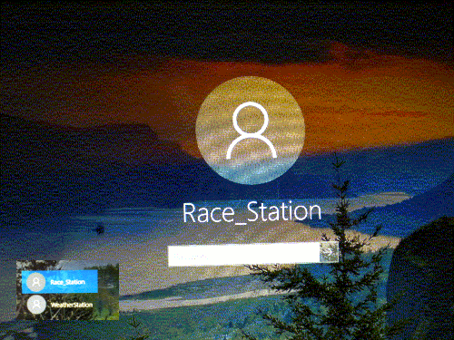
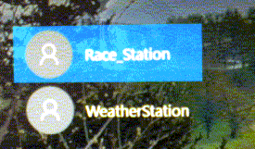
This is called the Login Screen.
(Ensure Race_Station is selected)
Enter Race Station Password racestation (case sensitive)

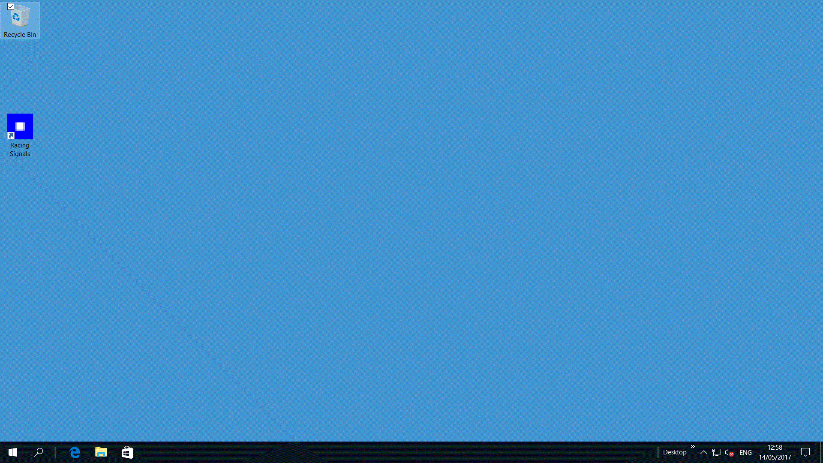
On Desktop (above) Double Click Racing Signals

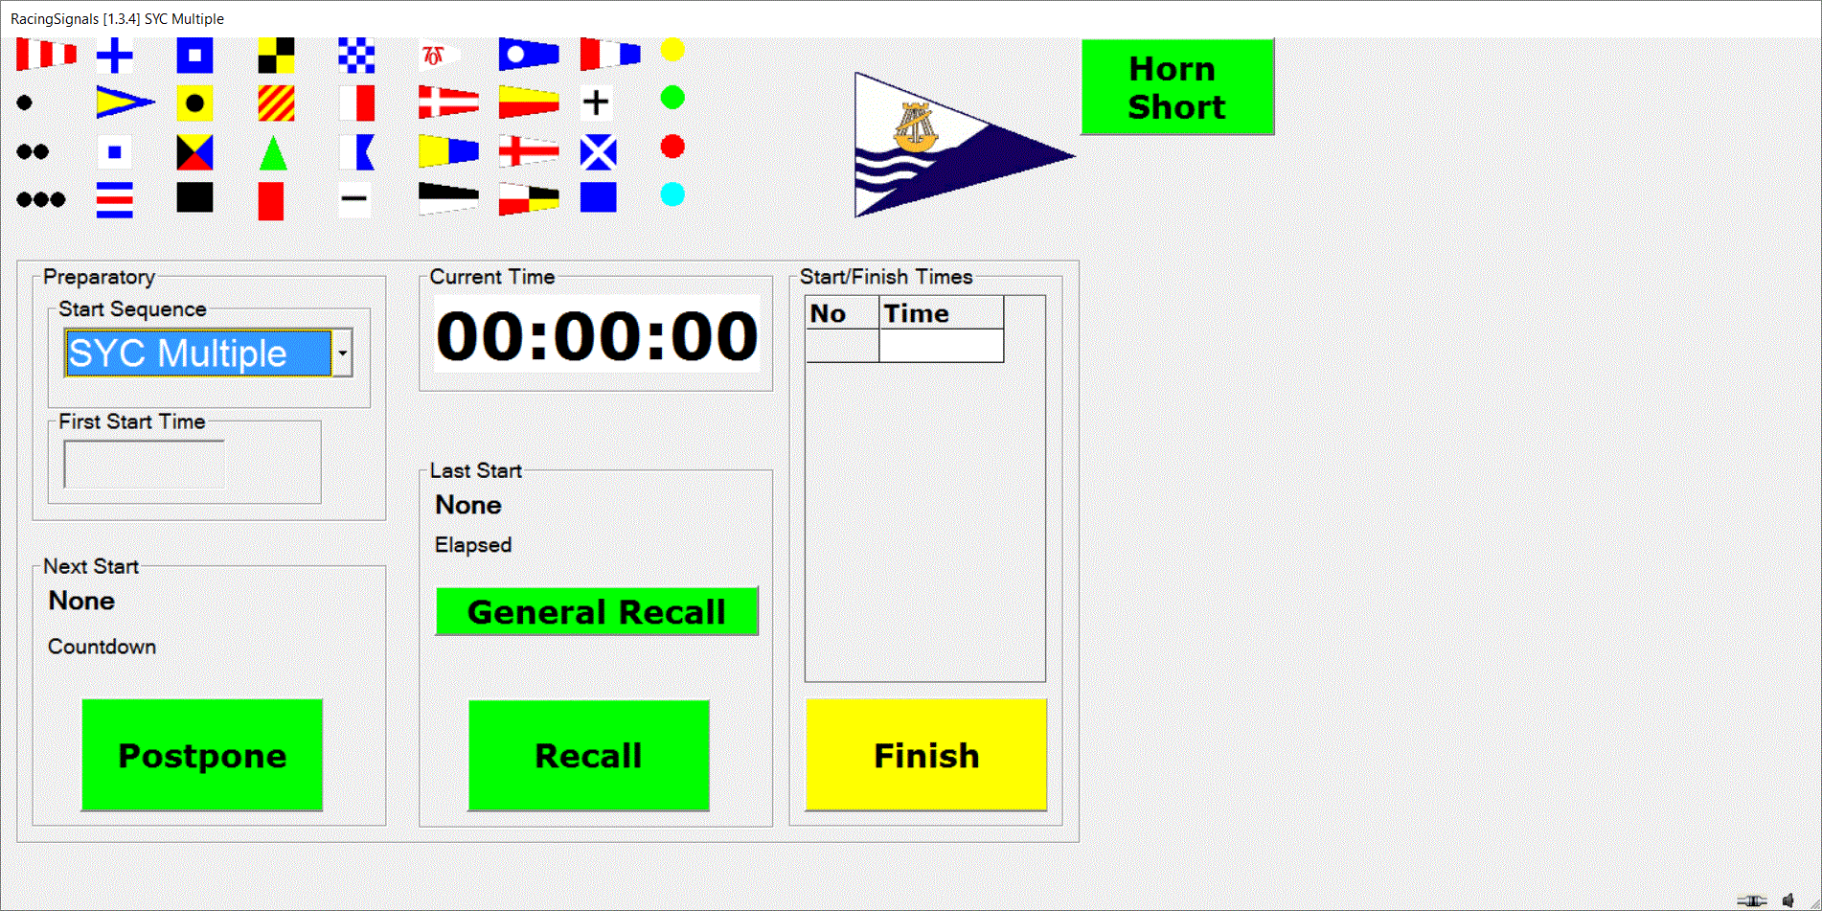
After a second this will change to
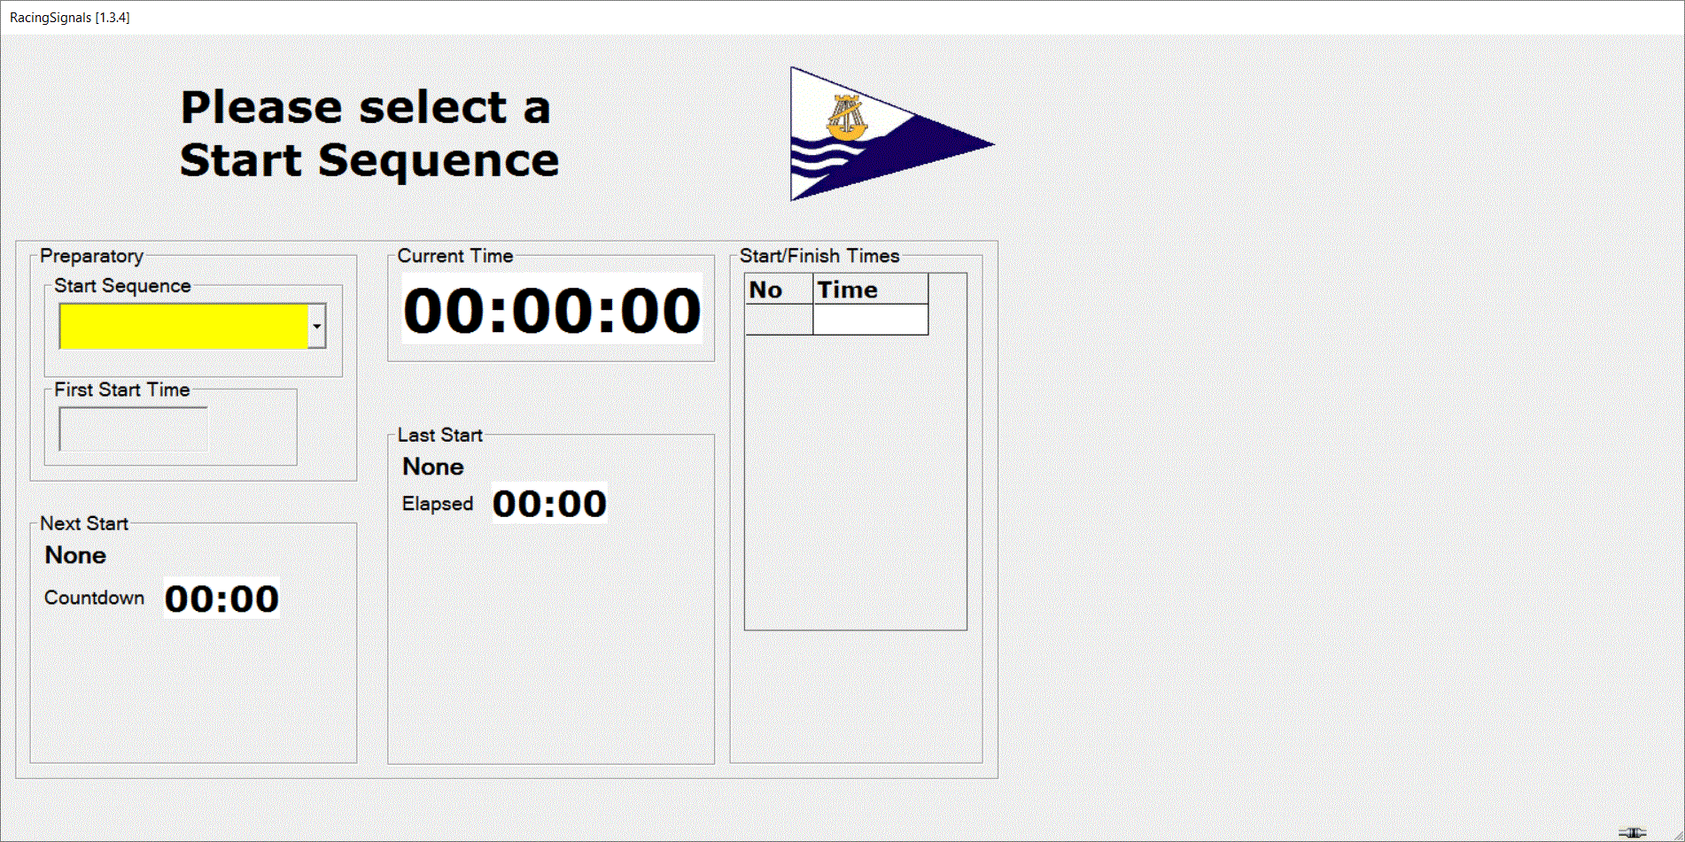
Click the Start Sequence Down arrow

There are 4 sequences to choose from
SYC Single & SYC Multiple are the basic sequences that emulate the current starting system.
For training purposes, X10 Run the sequences at 10 times the “normal” speed
Terminate exits the program.

Click the required sequence

To start a sequence you must enter a start time in 24 hour format in whole minutes.

Enter the Start Time (24 hour clock format with no punctuation marks)
915 is incorrect and must be entered as 0915. To clear errors use the delete key.
The First Start Time will be displayed in red until a valid time is entered

The start time must be before the first warning signal time.
If the First Start Time is into the next day you will see this error message

Click Cancel if the start is not tomorrow.

There are 4 buttons controlled by the start sequence, Postpone, Recall, General Recall and Finish plus a Horn button. A button is only active if it is coloured Yellow or Green. If Touched when Yellow, the button will turn Green for the duration of the signal. Clicking the button whilst Green will terminate the signal.

For example, the first click of the Postpone will raise the Postpone flag making the associated sound signal , the second click will lower the Postpone flag making .

During a start sequence, if a signal is invalid, the associated button will be “greyed out”

The Recall and General Recall buttons are enabled at the Class Start time and will remain enabled for 30 seconds. Clicking either will make the appropriate Sound and Light signals. The button will remain enabled until the button is Clicked a second time or 4 minutes has elapsed.

After the last Class has started and Recalls have timed out, the Finish button is activated

Clicking the finish button or pressing <Enter> will create an entry in the Finishing table.

Once a start sequence is running, the only way to reset it is to reload the sequence again and entering a new start time.

To Terminate the Program
Click the Start Sequence Down arrow
Click Terminate
Click OK

Turn off the power to the screen (button on bottom right)

DO NOT LOG OFF or SWITCH OFF PC

Controller
The icon is displayed when the PC is connected to the controller, or when not connected.
The icon is displayed if a sound card has been found on the PC.

